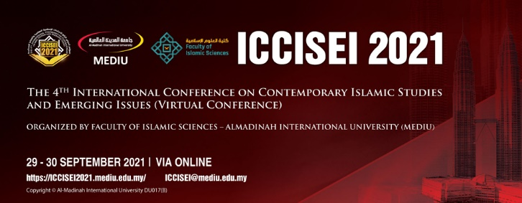

Paper Abstract
Personal details
Full Name
Passport/ID Number
Nationality
Official/Academic Title
Occupation
Affiliation
Address
Hand phone/ Fax
Email Address
Paper’s Title
Abstract: In 350 words or less, should be
In one paragraph, and to consider the following elements: Problem Statement, Aims, significance, methodology, important results.
Notice: please send this form along with a personal photo and a copy of your CV to this email address: ICCISEI@mediu.edu.my

